# **Chapter 2: Sharing is caring - The evolution of communal roosting behavior in birds**

**Introduction**

[**https://www.publish.csiro.au/book/7130#preview**](https://www.publish.csiro.au/book/7130#preview)

**Key word: local enhancement**

**file:///C:/Users/sandracd/Downloads/1312102.pdf**

**Thoughts as I am reading:**

**Could communal roosting be more frequent in less predictable landscapes (eg more natural?) versus more stable (human-dominated, that have carrion more available) in condors or other scavengers? Can we test this with movement data?**

Communal roosts are aggregations of unrelated individuals (either con- or heterospecific) that spend the resting period (either diurnal or nocturnal) together (Laughlin et al. 2014). This behavior is striking given the apparent little benefits of sharing space and resources with unrelated individuals. Yet, it is seen in species across many taxa, including fish (Clough and Ladle 1997), mammals (Kunz, 1982) and birds (Eiserer 1984). The frequency and diverse range of species in which communal roosting occurs suggest that it has evolved independently on numerous occasions, and that there should be an underlying mechanism, or set therefore, that support(s) this behavior.

It has been argued that these roosts are sites where naïve individuals can potentially exchange information with more experienced individuals on the location of food sources. This concept is formalized by Ward and Zahavi (1973) via the Information Center Hypothesis (ICH). Some prerequisites have been proposed by Mock (1988) to successfully test the ICH. First, *site fidelity*: individuals commute from specific roost sites to a recently detected carcass. Second, *differential success*: individuals differ in the information they have regarding food locations a given moment. In other words, there are informed and naïve individuals. Third, *signal transfer*: informed individuals may be identified by others through reliable physical (e.g., visual cues) or behavioral signals, either intentionally or inadvertently. This will allow for uninformed individuals to follow informed individuals. Fourth, *tolerance:* food resources are typically larger than the feeding capacity of a single individual, leading to satiation. Hence, information on location of food sources has little costs for the informed individual. Lastly, it is assumed that the cost of being a follower has an overall positive payoff than exploring for food individually. If the ICH holds true, individuals that exhibit communal roosting behavior are expected to have increased foraging efficiency than those who do not (e.g., Harel et al. 2017). Undoubtedly, this would be beneficial for scavengers given the high competition for their pulsed food resources (Van Overveld et al. 2022).

In an attempt to answer this question, the drivers for the communal roosting behavior in 201 bird species were tested by Beauchamp (1999), and his findings suggested that increased foraging efficiency was the most likely cause for communal roosting behavior. Other studies on specific species support this idea (Dermody et al. 2011). The conclusions on the aforementioned studies altogether open a new avenue for research to test this hypothesis in several other systems. Although the ICH has been well studied conceptually, these ideas have not been tested yet on a broader taxonomic scale after Beauchamp’s study, and a general understanding of the factors influencing avian communal roosting behaviour remain unknown. Using the comparative method, this chapter will focus on answering the following research question: what biological variables affect the prevalence of communal roosting behavior in landbirds?

**Methods**

Here, I will use the comparative method to explore the evolutionary relationship between physiological and biological traits and the communal roosting behavior in landbirds (*sensu* Felsenstein 1985) comprising roughly 8373 species. The traits selected for the analysis are body mass (kg) and diet breadth following Beauchamp (1999), and others like defensibility of food sources, Hand-wing index (HWI), trophic guild and memory. A rationale as to why these potential explanatory variables were selected follows:

* Dietary breadth: Specifically, I expect that species with low diet breadth may obtain less benefits from CRB as for low values (niche specialists), sharing information on food sources might not benefit the individuals; conversely, they might benefit from defending the resource. For species with high values of diet breadth (niche generalists), however, they do benefit from sharing as their resource might not be as limited. Data on diet breadth will be retrieved from the literature on number of prey items. The main database will be Birds of the World (hereon BOW, <https://birdsoftheworld.org/bow/home>) but complementary information will be obtained through search engines.
* Prey size to predator size ratio: The defensibility of the food source is expected to reduce CRB given that if food patches can be defended, there are no benefits of sharing with conspecifics (*sensu* Grant 1993). To test for defensibility of food sources, I will use a ratio between prey size and predator size (henceforth termed the ‘defensibility ratio’). The smaller the ratio, the more defensible the food source is expected to be.
* Trophic guild: Trophic guild follows a comparable pattern, where scavengers are expected to rely more on CRB given the unpredictable nature of their food sources (Harel et al. 2017). Data from Trophic guild will be obtained through AVONET, an online database for all bird species. Complementary information will be used to adjust for these categories where pertains.
* Hand-wing Index (HWI): Hand-wing index is a metric of dispersal ability in birds (Arango et al., 2022) and therefore it indicates the capacity of a species to scout looking for food sources. Where HWI is high, CRB may bring more benefits as they might access food location over broader areas that can be then accessed by others through information sharing (Buckley 1997). Hand-wing Index values will be obtained through AVONET.
* Memory: Memory was chosen as, for species to share information, memory on the location of the food source is required to be later passed on (G Hernández-Montero et al. 2020). To test for this variable, relative brain size (absolute brain size in relation to body mass) following van Overbeld et al. (2022).
* Mass: Finally, mass was selected *a priori* from a larger pool of co-variates to reduce correlation between parameters. For instance, body mass, average lifespan and clutch size can potentially have an effect on communal roosting behavior given that larger, long-lived species tend to rely on information sharing to meet their greater energetic demands. Mass values will be obtained through AVONET.

The species selected to test my hypothesis will be core land birds (Brusatte et al. 2015) as aquatic species are likely to follow significantly different foraging strategies (e.g., nesting and roosting sites are not differentiated which challenges disentangling the reason for roosting behavior). Communal roosting behavior will be classified as a Bernoulli variable where 0 is non-roosting behavior, and 1 is complete roosting behavior. Species for which this behavior is not properly documented will be classified as data deficient, and excluded from the analysis. Phylogenetic relationships between species will be obtained from <https://vertlife.org/>.

Figure 2.1 below shows the anticipated relationships between avian communal roosting behavior and the variables tested.

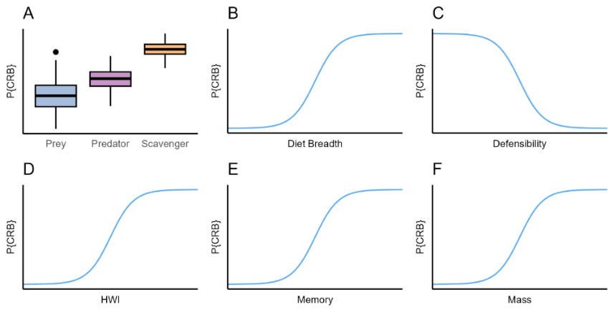

Figure 2.1. Anticipated relationships between the selected biological traits and the probability of Communal Roosting Behavior (p{CRB}). A) Trophic guild and Probability of Communal Roosting Behavior, where it will be considerably more probable in scavengers than in other trophic guilds. B-F show continuous biological variables and the expected relationship with P{CRB}.

*Statistical analyses*

The evolutionary relationship between communal roosting behavior (CRB) and will be modelled using Equation 1.

Eq. 1

Where CRB is the Communal Roosting Behavior, and is the regression coefficient that determines the relationship between the variables. The model will be fitted in R using the *brms* package using a binomial error distribution.

**Preliminary results**

A preliminary analysis conducted on 120 species of *corvidae* shows a positive correlation between HWI and mass and CRB (Fig. 2.2). In addition, trophic guild shows a clear pattern as well, with omnivores having a strong signal for communal roosting behavior (Fig. 2.2).

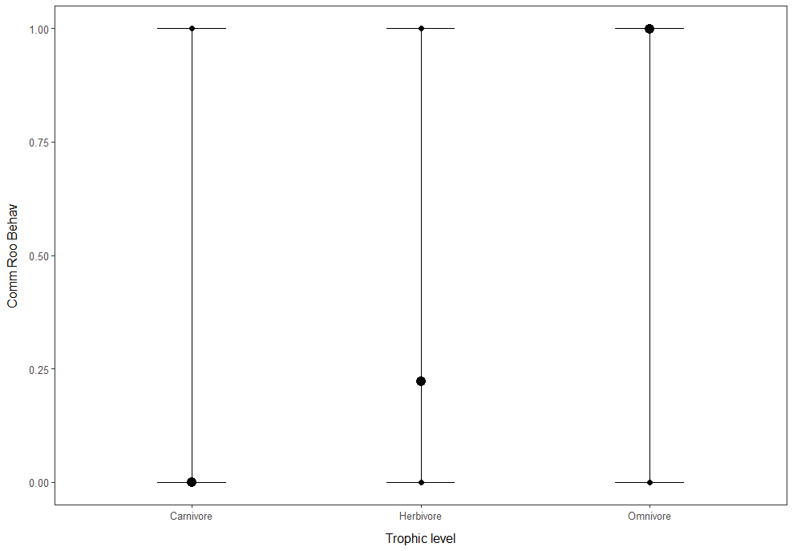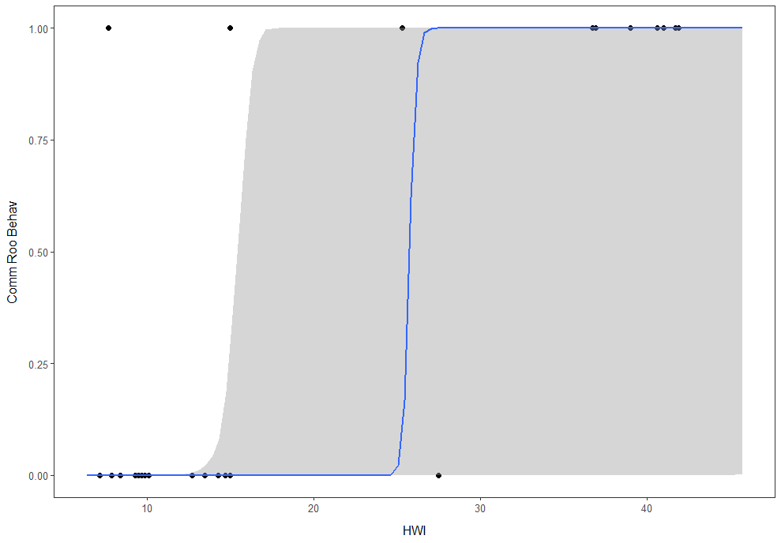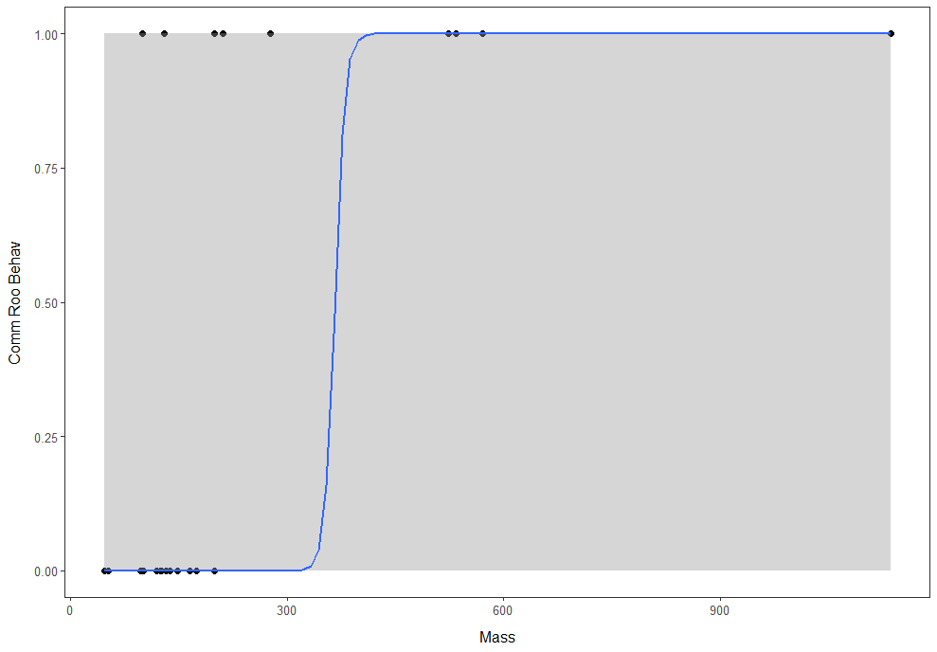

Figure 2.2. Communal Roosting behavior and biological variables

**Discussion and future work**

Preliminary results show patterns in line to those proposed by my hypothesis (Fig. 2.1). However, further analysis will be needed to add more detail on trophic guild (e.g., obligate and facultative scavengers included), as well as more bird species. Other variables still remain to be tested and finally variables modelled to determine which ones have a stronger effect on CRB.

# **Chapter 3: The origins of ballistic motion**

**Introduction**

An approach to understand foraging behavior is through encounter rates, in which ballistic (linear) motion is a more efficient way to find food in the landscape (Börger et al. 2008). As with other types of movements, ballistic motion can be affected by a variety of biological variables intrinsic to the species, or by landscape variables. For instance, a study by Noonan et al. (2023) showed that this motion differed between predator and prey mammals, being more frequent in predators provided everything else remains constant. In a similar fashion, landscape variables can act impact ballistic length scales. For instance, a study by Tucker et al. (2019) showed that some birds travel over greater distances in homogeneous environments. Several other studies have proposed frameworks and reviewed the topic in different taxa (e.g., Strien & Grêt-Regamey 2016).

Using an exploratory and comparative method, I will focus on answering the following research question: what biological and landscape variables affect ballistic length scales of landbirds? The purpose of this chapter is to provide the framework to answer my research question.

**Methods**

Following Noonan et al. (2023), I will estimate the average ballistic length scale *lv* (in m) for landbird species using GPS tracking data from Movebank, or from other collaborators. Datasets will be filtered to use species or individuals that are range residents only the range-resident portion of the annual cycle for migratory species. To do so, we will plot the semi-variance as a function of time lag and use variograms to identify a clear asymptote over time. I will use the Continuous Time Movement Mode package (here on ctmm) in R (version 4.2.2). Movement models will be fitted for every individual, and we will select only those individuals for which an Ornstein Uhlenbeck Foraging (OUF) model is the best-fit model following AICc. as it contains all the parameters required to estimate *lv*. The following equation will be used to determine the length over which ballistic motion persists (Eq. 2.):

Eq. 2

Where σp is the variance of the animal’s movement process (in m2), and τp and τv refer to the positional and velocity autocorrelation timescales respectively.

The hypotheses tested are outlined below:

*Ballistic length scales and communal roosting behavior*

Following Beauchamp (1999), I predict that the presence of communal roosting behavior will shorten ballistic length scales given that roosts act as an information center which should increase foraging efficiency, hence individuals will spend less time exploring. As such, within a same trophic guild, species that exhibit communal roosting behavior will have shorter ballistic length scales than those that do not (Figure 4a, 4b). In addition, because individuals within a communal roost act as a group altogether, I predict that ballistic length scales of one individual alone can be greater than that of other species, but that taken collectively, the group value will be significantly shorter as they are increasing the foraging efficiency of the group.

*Ballistic length scales and biological variables*

It has been discussed in the literature that predators tend to sustain longer scales of ballistic motion given that the main driver for movement are bottom-up forces- the need to look for resources like prey (and to a less extent social partners. Thus, for predators and scavengers, ballistic movement is seldom restrained by prey availability. Hence, I expect that overall, these species will have greater ballistic length scales than prey (other birds). The biological covariates discussed in chapter 2 will be used for this analysis.

*Ballistic length scales and environmental variables*

Temperature

Temperature ranges are an indicator of stability of the environment, and therefore can be used as predictability of food sources. Here, I expect species that inhabit more stable environments (e.g., tropical regions or tropical climates with little annual temperature changes) will show less persistence of ballistic motion because the food sources are more abundant, and therefore commuting long distances for food search is less required.

Thermal density (TD)

I will explore the relationship between presence of thermals, wind direction and velocity and the persistence of ballistic motion (Figure 4f). Here, I predict that overall, the presence of thermals and updrafts will be highly positive correlated to the persistence of ballistic motion as it aids movement (Pekarsky et al. 2023), but this correlation will be greater for soaring species, whilst for other species the correlation will not be as strong.

Environmental productivity (EP)

It is expected that the persistence of ballistic length scales is a function of the productivity of the environment. In general, in resource-poor environments, species will tend to have a longer ballistic motion since competition for resources is stronger, and because species will have to be actively seeking for scarce resources (Figure 4c, 4d). To test this hypothesis, I will use Normalized Difference Vegetation Index (NDVI) raster layers as a measure of productivity for terrestrial environments, and a raster layer of environmental variance derived from the NDVI layer.

Human Footprint Index (HFI)

Finally, I will evaluate the relationship between degree (0-1) and type of landscape disturbance (measured through Human Footprint Index) and the length of ballistic motion across prey and predator species. I predict that human transformed landscapes will increase the length of ballistic scale mostly for predators because these areas will reduce natural prey availability, and so, search will occur over larger areas (Figure 4e). However, this behavior might vary depending on the plasticity of the species. For some generalist species, under these disturbed conditions, they will rely mostly on artificial food sources (e.g., dumpsites or farms) which require less hunting effort. Hence, ballistic motion scales can be potentially reduced given that predictability of food resources increases.

The relationship between the aforementioned variables and CRB will be modelled using Eq. 3.

Eq. 3

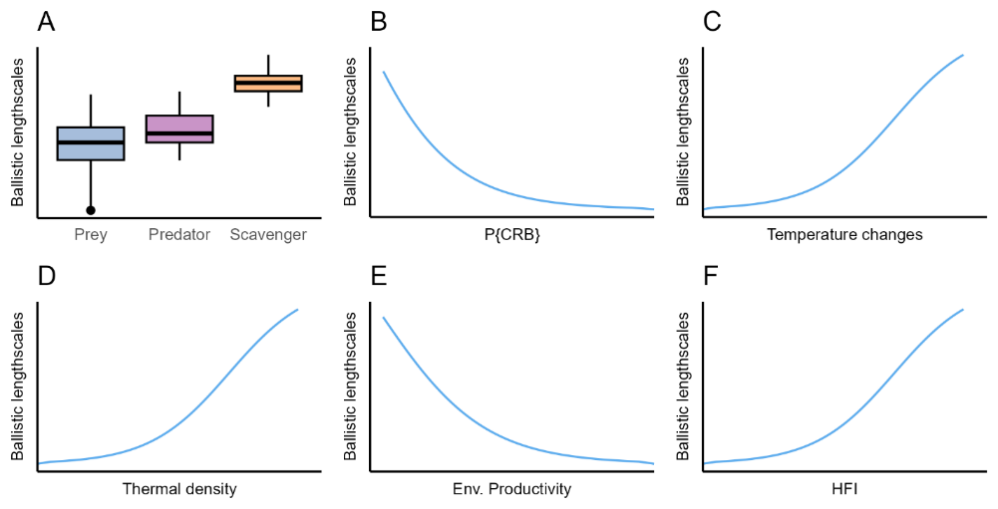

Figure 3.1. Anticipated relationships between the selected biological and environmental factors and ballistic length scales. A) Trophic guild and Ballistic length scales, where it will be considerably more probable in scavengers than in other trophic guilds. B-F show continuous biological variables and the expected relationship with Ballistic length scales.

Following similar methods as those described in chapter 2, I will run a phylogenetic analysis to correct for evolutionary relatedness in the species assessed using the brms package.

**Preliminary results**

To test for ballistic motion, I used AKDE values of home-range size (as a proxy for variance), τp and τv. These values will later be corrected with the variance value and expanded to more species. The preliminary results are shown in Figure 3.2 below.

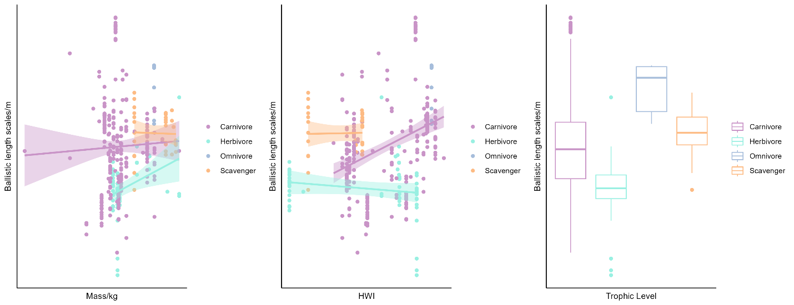

Figure 3.2. Relationships between selected biological variables and ballistic length scales (m) according to trophic level and confidence intervals.

**Discussion and future work**

The preliminary results of the analysis show an overall positive trend between mass and ballistic length scales, though notably weaker than that observed in mammals (Noonan et al. 2023), with stronger correlation in herbivores specifically. For HWI and ballistic length scales the relationship is non-conclusive as herbivores seem to have a negative correlation whereas carnivores show a stronger positive correlation. Moreover, ballistic length scales are greater for omnivores overall according to the preliminary analysis as compared to other trophic levels. Further analysis will be done to account for other biological variables (e.g., memory) and environmental variables shown in Figure 3.1 to compare with the predictions outlined above, as well as incorporating data for other bird species. These models will be used to evaluate whether there is an observed pattern in the persistence of ballistic length scales. The results will be discussed in the context of encounter rates and foraging efficiency.

**Chapter 4: The energetic value of social information**

**Introduction**

For most avian species, the fundamental form of locomotion is flight, and consequently understanding the energetic costs of the different flight modes can give information on their flight choices and the paths taken – in essence, flight behavior (e.g., Nussbaumer et al. 2022). Currently, a classic approach to understanding flight costs is derived from the mechanical power curve (Tobalske et al. 2003). This curve shows the relationship between flight velocities and metabolic rate, which is related to the power generated by pectoral muscles for movement. However, even more important is the metabolic power curve, which measures oxygen consumption rate of the individual. This is because overall, animals are only able to convert food and oxygen into mechanical work with an efficiency of 10-30%, hence, this is a more accurate way to measure energetic costs. Although there are several approaches to calculate energy expenditure, the models proposed by Guigueno et al. (2019) do not require laboratory work and rely solely on flight and physiological data of the species assessed. These models can be used to calculate the energy expenditure for different flight modes. The purpose of this chapter is to provide the methods used to quantify energy expenditure associated with ***search*** behavior and its relation to sociality in birds.

**Methods**

I will compare the energy expenditure between birds with social and non-social behavior.

1. Energy expenditure

To quantify energy expenditure, I will first calculate mechanical power (Pmech), measured in watts, according to Pennycuick (2008) since it is one of the most widely used across groups, allowing for comparisons. The formula used is shown below:

where body mass m is in kg, wingspan B is in m, airspeed V is in m/s, Sw wing area is in m2. The velocity data for ***search*** will be obtained from tracking data. ***Search*** movement will then be used to obtain the speeds of this segment using speed function in the ctmm package and the average value will be used in the formula. With this information I will then calculate metabolic flight costs (P*met*) in watts as:

P*met* has been calculated for several species and values are reported in the literature. This information can be used to model and estimate parameters α, β, and γ, which have been done by. These values are then used to calculate whole-body efficiency (η) following Guigueno et al. (2019):

η = (αmβ + δ + γV)−1

With this value, I can now calculate P*met* for all other species. A correction for this formula is currently being proposed by collaborators at the Max Planck Institute to account for wind impact on velocities, and their methods will be used to adjust the Pmech estimation, especially for soaring species.

1. Sociality

To account for sociality in birds (and the potential for socially derived information), I will use two main features: communal roosting behavior and probability of encounter rates within a population. For CRB I will use the database used in chapter 2. Birds will be classified into two groups, communal roosting birds (1) and non-communal roosting birds (0). For communal roosting birds, I will calculate the probability of encounter rates of individuals within a population using the pKDE function in ctmm. Here, I predict that the greater the encounter rate, the less energy used as they would presumably have access to more information on feeding sites. Here, the assumption is that in every encounter there is information being shared. However unlikely, it is still a good proxy for information on feeding sources. Hence, they are the most reliable group for which this assumption can be made. Another assumption made is that individuals are not receiving information from other sources (e.g., individuals outside the population). This assumption cannot be accounted for, but will be discussed in the analysis. Finally, it is also assumed that all individuals have equal access to the original food source location. To correct this assumption, I will use a measure of landscape productivity (NDVI) and distance to roads (due to roadkills) as a proxy for resource availability, and this will be used in the model to adjust for access to information. Complementary, non-communal roosting birds will be used as a null model.

Hypotheses tested:

*Metabolic flight costs and biological variables*

I predict that as expected from the equations above, body size (larger species) and trophic guild (predators and scavengers) will have greater general metabolic flight costs, whereas flight type (soaring species) will have lower metabolic flight costs.

*Metabolic flight costs and environmental variables*

Similarly, I predict that species that inhabit environments with low productivity (deserts and alpine regions) will tend to have lower general metabolic flight costs. This because I expect an increase in overall body efficiency to compensate for lower food sources available.

*Metabolic flight costs, communal roosting behavior and encounter rates*

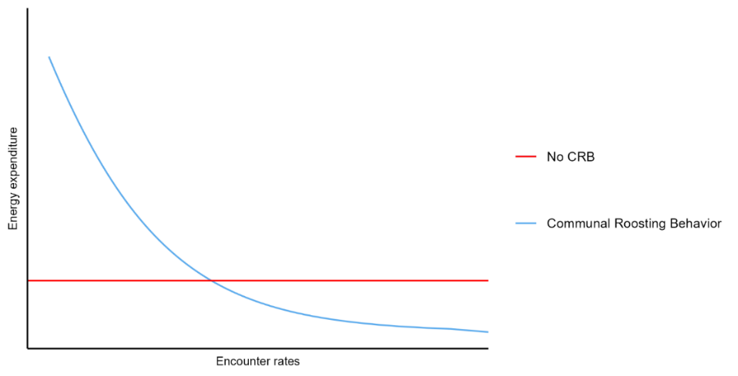If communal roosting behavior improves foraging efficiency, I expect species that exhibit this behavior to have lower metabolic flight costs as they would spend less time searching for food since the information on location is shared among individuals. Furthermore, for CRB species, the greater the encounter rates an individual has, the less the energetic cost of flight per unit time.

Figure 4.1. Relationships between encounter rates and energy expenditure during flight grouped by Communal Roosting Behavior

**Preliminary results**

The preliminary results between energy expenditure (measured as Pmech) and encounter rates for 10 individuals of *Gyps fulvus* is shown below in figure 4.2. Overall, trends do not seem conclusive at the moment, however this can be due to the small sample size assessed at the time being.

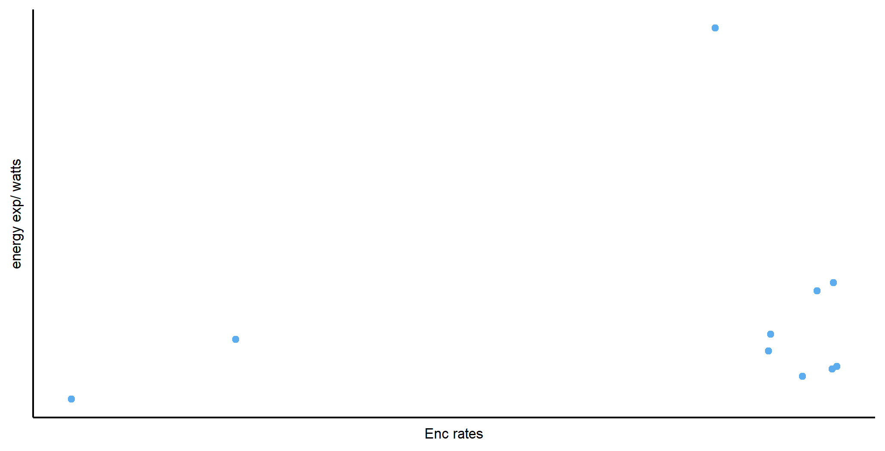

Figure 4.2. Relationships between encounter rates and energy expenditure during flight for 10 individuals of *Gyps fulvus*

**Discussion and future work**

To expand the scope of this analysis, I will be adding more individuals to the data analysis for this population, as well as assessing populations of other species. Furthermore, the energy calculation will be done in more detail using metabolic power (P*met*).

# **Chapter 5: Size matters: The Andean Condor – A peculiar case study**

**Introduction**

With a wingspan of 320 cm, females weighting up to 11 kg and males up to 15 kg (Houston et al. 2020), the Andean Condor (*Vultur gryphus*) is the heaviest extant soaring bird. It is an obligate scavenger, and a highly social species (Donázar et al. 1999), that uses communal roosts when they are not breeding, with aggregations adding up to 50 individuals. Despite their widespread distribution, large portions of the population occur in specific locations, with high concentrations occurring in these communal roosts. Because of their size and their obligate soaring ecology, they need to be highly energetically-efficient. Thus, communal roosts must be located in areas with uplift and thermals availability that they can exploit to commute to and from foraging grounds. Hence, I will show how communal roosts are areas of high conservation priority. As with many other vultures, Andean Condor populations are decreasing throughout its range, with all major threats being anthropogenic. In particular, habitat loss, poisoning due to human-wildlife conflict and wind power development are of greater concern, which frequently act synergistically. Because of their size, ecology (e.g., long lifespan, low reproductive rates, obligate soaring species – which requires longer learning periods (Hertel et al. 2023), scavengers), behavior (social species), and conservation status (globally Vulnerable), this emblematic Andean species is a peculiar study system and good model (Poessel et al. 2018) to test the hypotheses outlined in all previous chapters as they represent an extreme in the spectrum of extant flying birds.

**Methods**

This chapter will be a data-driven literature review based on the previous chapters. I will focus on calculating and comparing the energetic requirements of movement associated to foraging for Andean Condors. I will use the methods described in chapter 4 to calculate the energetic cost of movement by comparing flapping versus soaring flights. With this calculation, I will estimate the amount of food needed to meet their energetic requirements. The food estimation will be based on the energy supplemented by domestic cattle and wild South American Camelids obtained from the literature. This analysis will reinforce the high energetic demands of large species like the Andean Condor, which in turn, highlights the relevance of the sociality within the species for efficient foraging. Hence, I will discuss the value of communal roosts as centers of information, and the importance of healthy population sizes to maximize encounter rates among individuals.

# **Chapter 6: Progress to date and Project timeline**

Complementary to working on my proposal, I have been working on side research projects, conferences, volunteering initiatives, and other related jobs and responsibilities with the university.

